Project Report
On

“FOREIGN DIRECT INVESTMENT DATA ANALYSIS USING TABLEAU “
by
Miss. XXXXX XXXXXX
“Your Course Name”
APPENDIX - I
CERTIFICATE FROM THE GUIDE

This is to certify that the Project work titled Sales and Marketing Data Analysis using Tableau Is a bonafide work carried out by Miss. “Your Name” Roll # 00000000 a candidate for the B.Com examination of the Institute of Management under my guidance and direction

SIGNATURE OF GUIDE
NAME XXXXX XXXXXX
DESIGNATION: Manager, Projects & Logistics
ADDRESS Maersk Line, C.G.House,
Mumbai
DATE: 20-03-2021
PLACE: Mangalore
TABLE OF CONTENTS
CHAPTER |  | DESCRIPTION | PAGE NO
1 |  | INTRODUCTION TO FOREIGN DIRECT INVESTMENT
 | 1.1 | WHAT IS “FOREIGN DIRECT INVESTMENT”
 | 1.2 | HOW A FOREIGN DIRECT INVESTMENT WORK
 | 1.3 | TYPES OF FOREIGN DIRECT INVESTMENT
2. |  | FOREIGN DIRECT INVESTMENT ANALYSIS TOOL TABLEAU
 | 2.1 | WHY IS BUSINESS INTELLIGENCE IMPORTANT
 | 2.2 | HOW BUSINESS INTELLIGENCE WORK
 | 2.3 | THE FUTURE ROLE OF BUSINESS INTELLIGENCE
3 |  | THE HYPER GROWTH OF DIGITAL ECONOMY
 | 3.1 | FOREIGN DIRECT INVESTMENT IN INDIA
 | 3.2 | FOREIGN DIRECT INVESTMENT GROWTH IN INDIA
4 |  | RESEARCH METHODOLOGY
 | 4.1 | FDI COMPONENTS REVISION
 | 4.2 | ECONOMIC REFORMS IN INDIA
 | 4.3 | FDI COMPONENTS REVISION
 | 4.4 | SOME OF THE PROBLEM OF FDI IN INDIA
5 |  | BUSINESS INTELLIGENCE MODEL
 | 5.1 | FDI OVER THE YEAR WITH FORECAST
 | 5.2 | GROUPING OF SECTORS
 | 5.3 | MOST VARIANT SECTOR
 | 5.4 | PROPORTION OF EACH FDI
 | 5.5 | CLUSTERING OF SECTORS
 | 5.6 | TREND ANALYSIS
6 |  | TABLEAU DASHBOARD
 | 6.1 | CREATING DASHBOARD
7 |  | CONCLUSION
8 |  | EXPERT COMMENTS
 |  | BIBLIOGRAPHY

LIST OF FIGURES

SL NO | NAME OF THE FIGURE | PAGE NO
2.2 | THE MODERN ANALYTICS WORKFLOW
3.2 | BUY – SIDE VS SELL - SIDE
4.2 | REAL GROWTH RATE IN GDP
4.3 | FDI COMPONENT REVISION
5.0 | FDI DATA ANALYSIS
5.1 | RBI ANNUAL REPORT
5.1.1 | FDI OVER THE YEAR WITH FORECAST
5.2 | GROUPING OF SECTORS
5.3 | MOST VARIANT SECTOR
5.4 | PROPORTION OF EACH FDI
5.5 | CLUSTERING THE SECTOR
5.6 | TREND ANALYSIS
6.1 | CREATING WORKSHEET
6.1.1 | CREATING MULTIPLE SHEET
6.1.2 | BLACK DASHBOARD SHEET
6.1.3 | DASHBOARD 1
6.1.4 | DASHBOARD 2

CHAPTER – 1
INTRODUCTION TO FOREIGN DIRECT INVESTMENT
The foreign exchange market is the largest highly and liquid financial market in the world with worldwide average daily turnover around $5.3 trillion, which makes foreign exchange highly global trading asset. Foreign exchange forms the basis of dealings for trade and other monetary transactions between economies of the world. Foreign exchange market operates with heterogeneous participants comprises of central banks, commercial banks, companies, brokers, fund managers, speculators and individuals. Central banks regulate the market for smooth and orderly operations with a broader objective of economic and financial development. On the other hand, other participants try to minimise the potential risk with the best possible way and try to maximise the profit. Presences of high volatility make the exposure management challenge since the global capital is highly volatile and purely depends on the performances in the economic fundamentals. Moreover, country-specific and market-specific investors sentiments also influence the same.
This volatile pattern in the foreign exchange market is extremely crucial for a country like India which has unfavourable trade balance and facing stiff competition in the global market. Foreign exchange market is one of the enormous financial markets having trading centres across the globe on which the sun never sets and operate in a virtual platform. It operates like other financial markets where the price of the currency is measured as the value of a foreign currency relative to domestic currency or vice-versa. A foreign exchange contract typically states the currency pair, the amount of the contract, the agreed rate of exchange. Highly dynamic nature of exchange rate necessitates and predict the behavior for minimizing the potential exposure. Understanding the foreign exchange rate movements is not only crucial for exporters and, importers but also other active market participants such as commercial banks, brokers, central banks, traders, speculators, tourists and investors.
For understanding the movements in the foreign exchange market, much emphasis is given on fundamental, behavioral, technical analysis along with central bank’s actions for currency management. Fundamental analysis involves the study of economic fundamentals of a country such as Gross Domestic Product (GDP), Balance of Payment (BOP) Position, Political Stability, Inflation, Interest Rates and Rating by major Global Credit Rating Agencies etc. No fundamental factors play an inevitable role as the market not always consensus with fundamental, but it has strong relations with sensitive factors. Behavioral factor like bandwagon effects, peers/social and rumors influence the participant's decision. Similarly, technical analysis uses exchange rate forecasting techniques based on historical movements in the market. Impact of fundamental and non-fundamental factors on the foreign exchange market has become a widely studied topic in academic literature. One side of this literature focuses on the impact of fundamental and non-fundamental factors, while the other on the role, efficiency and use of technical analysis by foreign exchange traders in generating trading signals. Some studies have reported from their survey of foreign exchange traders that non-fundamental factors such as bandwagon effects, over-reaction to news, technical trading, and excessive speculation determines short-run exchange rate and the role of fundamental factors in relevant in the long run. Previous literature on technical analysis provides that technical analysis is an important and widely used method of analysis in the foreign exchange market and that applying certain technical trading rules over a sustained period may lead to significant positive excess returns. Most of these studies have however been limited to major developed countries and some developing countries excluding India. These results might differ between the countries as it depends on the specific country’s market regulations, ‘maturity’ and the economy itself.
Motives for central bank interventions in the foreign exchange market are clearly available and supported by the academic literature. But the impact of central bank interventions on foreign exchange volatility and its relationship with technical rules profitability is still unclear. Some studies on a survey of foreign exchange dealers have reported that central bank intervenes with the objective to bring stability in the market have an intervention which reduces volatility; whereas other studies have reported from their survey evidence that central bank interventions increase volatility in the market. This contradiction needs to be addressed and has aroused the necessity to identify the existent impact of central bank interventions on foreign exchange volatility so that behavior of the market to intervention practices can be understood clearly. Studies on central bank interventions and technical trading rules profitability provides that trading rules are unusually profitable on days on which interventions take place, so the same needs to be investigated in the Indian context.
This study primarily investigates the dynamic characteristics of Indian foreign exchange market including perception and attitude of the market participants to forecasting the exchange rate with an artificial neural network technique. It specifically examines the relative importance of fundamental as well non-fundamental that influence foreign exchange rate predictions and their time-varying behaviour in the market. Similarly, it explores the significance of fundamental and non-fundamental factors in the trading decision of foreign exchange traders. Study tries to discover an appropriate model to forecast the exchange rate movements of INR-USD; INR-GBP, INR-JPY and INR-EUR. Further study assesses the impact of central bank interventions by measuring the extent of the volatility of the Indian foreign exchange market due to Central Bank interventions. Finally, study recommend measures for policy makers, investors and corporate on the basis of the findings from the present study.

1.1 : What is “Foreign Direct Investment”
A foreign direct investment (FDI) is an investment made by a firm or individual in one country into business interests located in another country. Generally, FDI takes place when an investor establishes foreign business operations or acquires foreign business assets in a foreign company. However, FDIs are distinguished from portfolio investments in which an investor merely purchases equities of foreign-based companies.
- Foreign direct investments (FDI) are investments made by one company into another located in another country.
- FDIs are actively utilized in open markets rather than closed markets for investors.
- Horizontal, vertical, and conglomerate are types of FDI’s. Horizontal is establishing the same type of business in another country, while vertical is related but different, and conglomerate is an unrelated business venture.
- The Bureau of Economic Analysis continuously tracks FDIs into the U.S.
- Apple’s investment in China is an example of an FDI.

1.2 : How a Foreign Direct Investment Work
Foreign direct investments are commonly made in open economies that offer a skilled workforce and above-average growth prospects for the investor, as opposed to tightly regulated economies. Foreign direct investment frequently involves more than just a capital investment. It may include provisions of management or technology as well. The key feature of foreign direct investment is that it establishes either effective control of or at least substantial influence over the decision-making of a foreign business.
The Bureau of Economic Analysis (BEA), which tracks expenditures by foreign direct investors into U.S. businesses, reported total FDI into U.S. businesses of $4.46 trillion at the end of 2019. Manufacturing represented the top industry, with just over 40% of FDI for 2019. Foreign direct investments can be made in a variety of ways, including the opening of a subsidiary or associate company in a foreign country, acquiring a controlling interest in an existing foreign company, or by means of a merger or joint venture with a foreign company.
The threshold for a foreign direct investment that establishes a controlling interest, per guidelines established by the Organisation of Economic Co-operation and Development (OECD), is a minimum 10% ownership stake in a foreign-based company. However, that definition is flexible, as there are instances where effective controlling interest in a firm can be established with less than 10% of the company's voting shares.

1.3 : Types of Foreign Direct Investment

Foreign direct investments are commonly categorized as being horizontal, vertical or conglomerate. A horizontal direct investment refers to the investor establishing the same type of business operation in a foreign country as it operates in its home country, for example, a cell phone provider based in the United States opening stores in China.

A vertical investment is one in which different but related business activities from the investor's main business are established or acquired in a foreign country, such as when a manufacturing company acquires an interest in a foreign company that supplies parts or raw materials required for the manufacturing company to make its products.

A conglomerate type of foreign direct investment is one where a company or individual makes a foreign investment in a business that is unrelated to its existing business in its home country. Since this type of investment involves entering an industry in which the investor has no previous experience, it often takes the form of a joint venture with a foreign company already operating in the industry.
Examples of foreign direct investments include mergers, acquisitions, retail, services, logistics, and manufacturing, among others. Foreign direct investments and the laws governing them can be pivotal to a company's growth strategy.
In 2017, for example, U.S.-based Apple announced a $507.1 million investment to boost its research and development work in China, Apple's third-largest market behind the Americas and Europe. The announced investment relayed CEO Tim Cook's bullishness toward the Chinese market despite a 12% year-over-year decline in Apple's Greater China revenue in the quarter preceding the announcement.
China's economy has been fuelled by an influx of FDI targeting the nation's high-tech manufacturing and services, which according to China's Ministry of Commerce, grew 11.1% and 20.4% year over year, respectively, in the first half of 2017. Meanwhile, relaxed FDI regulations in India now allows 100% foreign direct investment in single-brand retail without government approval. The regulatory decision reportedly facilitates Apple's desire to open a physical store in the Indian market. Thus far, the firm's iPhones have only been available through third-party physical and online retailers.

CHAPTER – 2

FOREIGN DIRECT INVESTMENT ANALYSIS TOOL TABLEAU

Business intelligence (BI) combines business analytics, data mining, data visualization, data tools and infrastructure, and best practices to help organizations to make more data-driven decisions. In practice, you know you’ve got modern business intelligence when you have a comprehensive view of your organization’s data and use that data to drive change, eliminate inefficiencies, and quickly adapt to market or supply changes.
It’s important to note that this is a very modern definition of BI—and BI has had a strangled history as a buzzword. Traditional Business Intelligence, capital letters and all, originally emerged in the 1960s as a system of sharing information across organizations. It further developed in the 1980s alongside computer models for decision-making and turning data into insights before becoming specific offering from BI teams with IT-reliant service solutions. Modern BI solutions prioritize flexible self-service analysis, governed data on trusted platforms, empowered business users, and speed to insight.
Much more than a specific “thing,” business intelligence is rather an umbrella term that covers the processes and methods of collecting, storing, and analyzing data from business operations or activities to optimize performance. All of these things come together to create a comprehensive view of a business to help people make better, actionable decisions.
Over the past few years, business intelligence has evolved to include more processes and activities to help improve performance. These processes include:
- Data mining: Using databases, statistics and machine learning to uncover trends in large datasets.
- Reporting: Sharing data analysis to stakeholders so they can draw conclusions and make decisions.
- Performance metrics and benchmarking: Comparing current performance data to historical data to track performance against goals, typically using customized dashboards.
- Descriptive analytics: Using preliminary data analysis to find out what happened.
- Querying: Asking the data specific questions, BI pulling the answers from the datasets.
- Statistical analysis: Taking the results from descriptive analytics and further exploring the data using statistics such as how this trend happened and why.
- Data visualization: Turning data analysis into visual representations such as charts, graphs, and histograms to more easily consume data.
- Visual analysis: Exploring data through visual storytelling to communicate insights on the fly and stay in the flow of analysis.
- Data preparation: Compiling multiple data sources, identifying the dimensions and measurements, preparing it for data analysis.

2.1 : WHY IS BUSINESS INTELLIGENCE IMPORTANT
Business intelligence can help companies make better decisions by showing present and historical data within their business context. Analysts can leverage BI to provide performance and competitor benchmarks to make the organization run smoother and more efficiently. Analysts can also more easily spot market trends to increase sales or revenue. Used effectively, the right data can help with anything from compliance to hiring efforts.
A few ways that business intelligence can help companies make smarter, data-driven decisions:
- Identify ways to increase profit.
- Analyze customer behavior.
- Compare data with competitors.
- Track performance.
- Optimize operations.
- Predict success.
- Spot market trends.
- Discover issues or problems.

2.2 : HOW BUSINESS INTELLIGENCE WORK
Businesses and organizations have questions and goals. To answer these questions and track performance against these goals, they gather the necessary data, analyze it, and determine which actions to take to reach their goals. On the technical side, raw data is collected from the business’s activity. Data is processed and then stored in data warehouses. Once it’s stored, users can then access the data, starting the analysis process to answer business questions.
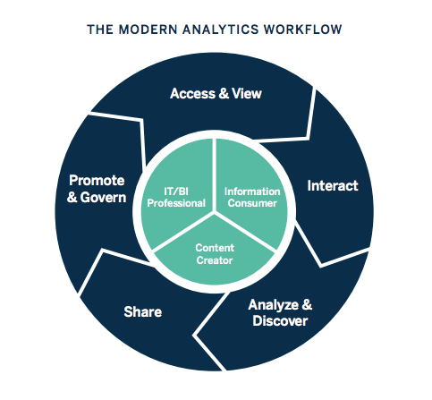
FIG NO. 2.2 : THE MODERN ANALYTICS WORKFLOW
Business intelligence includes data analytics and business analytics, but uses them only as parts of the whole process. BI helps users draw conclusions from data analysis. Data scientists dig into the specifics of data, using advanced statistics and predictive analytics to discover patterns and forecast future patterns. Data analytics asks “Why did this happen and what can happen next?” Business intelligence takes those models and algorithms and breaks the results down into actionable language.
2.3 : THE FUTURE ROLE OF BUSINESS INTELLIGENCE
Business intelligence is continually evolving according to business needs and technology, so each year, we identify current trends to keep users up-to-date on innovations. Realize that artificial intelligence and machine learning will continue to grow, and businesses can integrate the insights from AI into a broader BI strategy. As companies strive to be more data-driven, efforts to share data, and collaborate will increase. Data visualization will be even more essential to work together across teams and departments.
This article is just an introduction to the world of business intelligence. BI offers capabilities for near real-time sales tracking, allows users to discover insights into customer behavior, forecast profits, and more. Diverse industries like retail, insurance, and oil have adopted BI and more are joining each year. BI platforms adapt to new technology and the innovation of its users. Stay up-to-date with all of the trends and changes in business intelligence as we list the top 10 current trends in BI.

CHAPTER – 3
THE HYPER GROWTH OF DIGITAL ECONOMY
While estimates vary widely:
- Retailing on the Internet accounted for less than 3% of total North American retail sales in 1998. Growth rates, however, have been very encouraging. It was estimated that in the year 2000 business-to-consumer Internet transactions worldwide has amounted to approximately $20-$50 billion, while business-to-business transactions has reached in the $50-$150 billion range.” (Industry Canada)
- Internet traffic is doubling every 100 days. Digital economy is doubling annually. Worldwide e-business was exceeded $1 trillion by 2002.(a survey)
- Canada is the most ‘wired’ nation, with the highest per capita rate of Internet-connected people. Forty-five percent of Canadians are online for a total of 13.5 million users. Americans rank first for the total number of users with 92 million people online, or 34 percent of the population. (NUA Internet Surveys, 1999)
- 61% of Canadian small and medium-sized enterprises (SME5) were connected to the Internet in 1999. (Internet Institute)
- Canada has the lowest Internet access cost in the world. (OECD, 1997)

3.1 : MARKET REPORTS AND INFORMATION ON THE CONSUMER ONLINE INDUSTRY:
- NUA Internet Surveys
- International Communications Inc.
- Jupiter Communications
- COM QUEST Research (Canadian data)
NEWS AND ANALYSIS.
China’s Mr. Internet: Jack Ma wants to build China’s first genuinely global Digital Economy firm - The Economist (Aug 26, 2000)
- Thinking Strategically about Selling Online - Ascenda
Home Internet use ‘growing’ - BBC News (Aug 7, 2000)
- Dairy industry turns to Digital Economy - CNN (Jul 28, 2000)
- Online shopping gets more convenient - BBC News (Jul 27, 2000)

ALL DIGITAL ECONOMY
- Digital Economy Times: getting started, strategies, news and reports.
- Focuses on buying and selling over the Internet, along with ongoing issues that will impact the future of electronic commerce.
- The Agricultural Forum (U.S.) has a series of papers on the effects of Digital Economy in the agri food industry.
- Digital Economy survey by The Economist

3.2 : TALKING’ ABOUT E-GENERATION
Student opinions report by The Economist, Most business owners understand the idea of conducting business over the Internet, and probably understand the need to “get their business online” but what is Digital Economy, really, and how do you get started?

In a nutshell, Digital Economy is a way of conducting business through computers and over networks. Simply put, Digital Economy is buying and selling over the Internet. But it’s actually much more than that. Business interactions of all types-from simple buying and selling, to complex business practices such as banking, manufacturing, and supply chain management-can be easily accomplished using the Internet along with real time data.
Buy-Side vs. Sell-Side: Digital Economy
There are two basic sides to Digital Economy; the Buy Side and the Sell Side
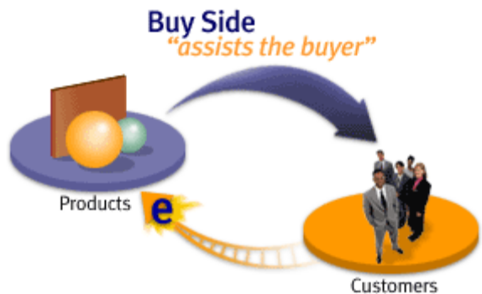
FIG NO. 3.2 : BUY – SIDE VS SELL - SIDE
Buy Side
Customers
Buy Side refers to the Digital Economy functionality that enables a business to sell their products to a buyer (customer) online. This buyer could be an individual consumer or a large company buying products for commercial use. The purpose is to make online buying easier and the experience more pleasant for the buyer. The more robust the choice in conjunction with an easier, user- friendly web site, customer satisfaction increases and so do sales.
Sell Side refers to the Digital Economy functionality that enables a company to actually make their goods and services available over the Internet. Critical to the success of the seller, it assists the seller in improving internal business processes and functionality. The purpose is to help companies increase revenue and profitability by reducing business and procurement costs. Since Digital Economy is a relatively new phenomenon, the definitions and jargon are not necessarily embedded into our everyday business lexicon.

CHAPTER – 4
RESEARCH METHODOLOGY
4.1 : FOREIGN DIRECT INVESTMENT IN INDIA
Today, India is perceived as the second most favorable investment destination. The global economic growth is becoming more and more dependent upon Asia’s growth, in which India is playing an increasingly more important role.

4.2 : ECONOMIC REFORMS IN INDIA
Major initiatives put forth as a part of the liberalization and globalization strategy since the early Nineties. With the announcement of the new industrial policy the strategy of industrialization followed is an “outward looking’ one. All manufacturing activities, except a few (due to strategic, environmental reasons, etc.) are now open to competition and the entrepreneurs are free to make investment decisions based on their commercial judgment.
Over the years, there has been a steady liberalization of the exchange controls with full convertibility on current account transactions. Various reforms towards the road to liberalization include:
• Virtual scrapping of the industrial licensing regime.
• Amendment of the Monopolies and the Restrictive Trade Practices Act
• Reduction in the number of areas reserved for the public sector
• Reduction in rates of both direct and indirect taxes and change over to market determined exchange rates.
• Launching of the privatization program • Opening of many new sectors to FDI.
• Raising FDI equity caps in sectors already opened and procedural simplification.
Today, the FDI policy in India is widely reckoned to be among the most liberal in the emerging economies and FDI up to 100% is allowed under the automatic route in most sectors and activities. FDI under the automatic route does not require approval of the Government and merely involves intimating to the Reserve Bank of India with 30 days of inward remittances and filing of documents within 30 days of issue of shares top foreign investors.
Along with the policies on inward FDI, the policies on outward investment are also liberalized. Various steps taken for liberalization of outward FDI are: • Controls on inward FDI and external commercial borrowing by domestic firms have been eased.
• The emergence of world-class Indian corporate is being encouraged by the lifting of controls on outward investment.
• Indian corporate can now invest up to 200% of their net worth overseas under the automatic route.
There has been a trend of increased overseas investments by Indian corporate.

4.2 : FOREIGN DIRECT INVESTMENT GROWTH OPPORTUNITIES IN INDIA
Industrial Licensing has already been liberalized in India since 1991. Reforms taken in Industrial licensing are:
• Now entrepreneurs are free to set up industries.
• Opening of Companies has been made simple.
• With the introduction of IT in operations of registrars of Companies, it has been made possible to open a company even in a day.
Registrations with tax authorities, local authorities and other are also were made IT friendly, thus resulting in lesser time taken. The Indian customs tariff rates have been brought down.

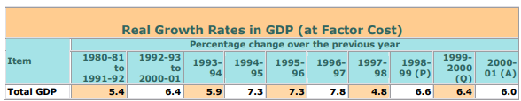
FIG NO. 4.2 : REAL GROWTH RATE IN GDP
The last decade has seen an annual average growth rate of around 6% per annum in India’s GDP. From the figures of H1 of 2005-06, GDP (at factor cost at constant prices) grew by 8.1% as against 7.1% in the corresponding period last year. Manufacturing GDP grew by 10.2% in H1 of 2005-06 as compared to 8.8% during the corresponding period last year. More importantly, India has been maintaining GDP growth of 6-8% year after year.

4.3 : FDI COMPONENTS REVISION
FDI reporting in India was capturing only the capital component provided by the investor. However, FDI, as per international practices of reporting, includes equity capital, reinvested earning (refer to Appendix - 1) and intra company loans. Government had undertaken an exercise for adoption of the international practice in compilation of FDI statistics. Based on the information so far collected, the RBI has revised the FDI inflow figures since 2001-02.

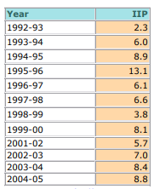
Fig No. 4.3 : FDI COMPONENT REVISION
The year 2004-05 witnessed further industrial recovery. The industrial growth, measured in terms of Index of Industrial Production (IIP), increased from 2.7% in 2001-02 to 5.7% in 2002-03, 7.0% in 2003-04 and further to 8.4% in 2004-05. The robust industrial growth continues and the IIP has grown by 8.8% during the period April-November2005 over the corresponding period last year.
Some of the factors that explain the recent spurt in FDI inflows into India are: • Progressive liberalization of FDI policy has strengthened investor confidence – opening up of new sectors (integrated townships, defense industry, tea plantations, etc.); removal of FDI caps in most sectors, including advertising, airports, private sector oil refining, drugs and pharmaceuticals, etc.; and greater degree of automaticity for investment.
• Liberalization of foreign exchange regulations by way of simplification of procedures for making inward and outward remittances.
• Sectoral reforms, especially in sectors such as telecom, information technology and automobiles have made them attractive destination for FDI.
• Policy to allow foreign companies to set up wholly owned subsidiaries in India has enabled foreign companies to convert their joint ventures into wholly owned subsidiaries.
• Public sector disinvestment has finally emerged as an important means to promote FDI.
• Government has set up an inter-ministerial Committee to examine the extant procedures for investment approvals and implementation of projects, and suggest measures to simplify and expedite the process for both public and private investment.
• The Foreign Investment Implementation Authority (FIIA) has been activated and now meets at regular intervals to review and resolve investment-related problems.

4.4 : SOME OF THE PROBLEM OF FDI IN INDIA
In this section we highlight some of the weakness and constraints on achieving higher FDI inflows into India. Not all are relevant to every originating country or every destination sector. Some factors are more relevant for first time investors with no previous experience of investment in India. Though economic reforms welcoming foreign capital were introduced in the nineties it does not seem so far to be really evident in our overall attitude. There is a perception abroad that foreign investors are still looked at with some suspicion.
There is also a view that some unhappy episodes in the past have a multiplier effect by adversely affecting the business environment in India. Besides the “Made in India” label is not conceived by the world as synonymous with quality. When a foreign investor considers making any new investment decision, it goes through four stages in the decision making process and action cycle, namely,
a) Screening,
b) Planning,
c) Implementing and
d) Operating and expanding.
The biggest barrier for India is at the first, screening stage itself in the action cycle. This is primarily because we do not get across effectively to the decision-making “board room” levels of corporate entities where a final decision is taken. Our promotional effort is quite often of a general nature and not corporate specific. India is, moreover, a multicultural society and a large number of multinational companies (MNC) do not understand the diversity and the multi-plural nature of the society and the different stakeholders in this country. Though in several cases, the foreign investor is discouraged even before he seriously considers a project, 220 of the Fortune 500 companies have some presence in India and several surveys (A T Kearney) [1] show India as the most promising and profitable destination.
On the other hand China is viewed as ‘more business oriented,’ its decision-making is faster and has more FDI friendly policies. Despite a very similar historical mistrust of foreigners and foreign investment arising from colonial experience, modern (post 1980 China) differs fundamentally from India. Its official attitude to FDI, reflected from the highest level of government (PM, President) to the lowest level of government bureaucracy (provinces) is one of consciously enticing FDI with a warm welcome.

CHAPTER – 5
BUSINESS INTELLIGENCE MODEL
India’s share in FDI inflows among developing countries reached a peak of 1.9 per cent in 1997. It declined sharply to 1 per cent in 1999 and 2000 but has recovered sharply to 1.7 per cent in 2001(Table 4). India’s performance on the FDI front has shown a significant improvement during 2001-02. FDI inflows grew by 65 per cent to US$ 3.91 billion during 2001-02 thus exceeding the previous peak of US $ 3.56 billion in 1997-98 (as per BOP2 accounts of RBI). This growth of 65 per cent is particularly encouraging at a time when global FDI inflows have declined by over 40 per cent. The upward trend in FDI inflows has been sustained during the current financial year with FDI inflows during April-June 2002 about doubles that during the corresponding period of 2001 (as per DIPP3 data).
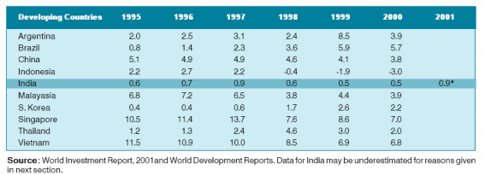
Fig No. 5.0 : FDI DATA ANALYSIS
Engineering, Services, Electronics and Electrical equipment and Computers were the main sectors receiving FDI in 2000-01 (Table 5). Domestic appliances, finance, food & dairy products which were important sectors attracting FDI in the early nineties, have now seen a downtrend in the latter half of the nineties. FDI into India apparently continues to grow. National sources estimate inward direct investment in 2005 at an all-time high USD 6.5 billion. This is likely to be an underestimate, as recent sectorial liberalization measures have ensured that an increasing proportion of inward FDI now arrives unscreened via the “automatic route”, requiring only notification to the central bank – an obligation that is not enforced and therefore widely ignored. Although manufacturing is generally open to foreign investment and there has recently been substantial liberalization of the FDI regime in some sectors, such as telecommunications, others, notably the retail industry, remain closed to foreign investors.
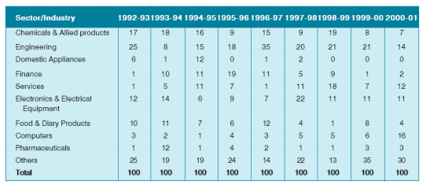
Fig No. 5.1 : RBI ANNUAL REPORT
Services and computer have seen an increasing trend in the latter half of the nineties. The inflow of FDI into computers increased from 6 per cent in 1999-00 to 16 per cent in 2000-01. On the whole there have been significant changes in the pattern and composition of FDI inflows with few clear trends over the decade as whole.
In 2001, the sectors that account for maximum FDI are fuel (power, oil refineries, gas); telecom; electronic goods, IT and software; automobiles; and services. The major investing countries are Mauritius (mainly routed from developed countries), USA, Japan, UK, Germany, the Netherlands and South Korea. The States that account for maximum FDI are Maharashtra, Delhi, Tamil Nadu, Karnataka and Gujarat. During the first half of 2002 the FDI inflows went mainly into transportation industry, services, telecom and electronics/IT/software. Direct investment in India is in public debate often linked with offshore outsourcing, especially in the information technology sector (though it should be noted that this is also an area of major domestic as well as foreign investment), but the real picture is more mixed. If borne out by the facts this could push up inward FDI further in the coming years and lead to an even stronger concentration in the service sectors.
In our Project, we have considered following business model, such as
- FDI Over the Year with Forecast
- Grouping of Sectors.
- Most Variation Sector.
- Proportions of Each FDI
- Clustering the Sectors
- Trend Line in FDI.

5.1 : FDI OVER THE YEAR WITH FORECAST.

Global foreign direct investment (FDI) flows are forecast to decrease by up to 40% in 2000, from their 2016 value of $40 billion, according to UNCTAD’s World Investment Report 2020. This would bring FDI below $1 trillion for the first time since 2005. In addition, FDI is projected to decrease by a further 5% to 10% in 2017 and to initiate a recovery in 2018, the report says.
“The outlook is highly uncertain. Prospects depend on the duration of the health crisis and on the effectiveness of policies mitigating the pandemic’s economic effects,” said UNCTAD Secretary-General Mukhisa Kituyi. The pandemic is a supply, demand and policy shock for FDI. The lockdown measures are slowing down existing investment projects. The prospect of a deep recession will lead multinational enterprises (MNEs) to reassess new projects. Policy measures taken by governments during the crisis include new investment restrictions.
Investment flows are expected to slowly recover starting 2020, led by global value chains (GVCs) restructuring for resilience, replenishment of capital stock and recovery of the global economy. Global FDI flows rose modestly in 2019, following the sizable declines registered in 2017 and 2018. At $1.54 billion, inflows were 3% up. The rise in FDI was mainly the result of higher flows to developed economies, as the impact of the 2017 tax reforms in the United States waned. “Despite the drastic decline in global FDI flows during the crisis, the international production system will continue to play an important role in economic recovery and development. Global FDI flows will continue to add to the existing FDI stock, which stood at $37 trillion at the end of 2019.

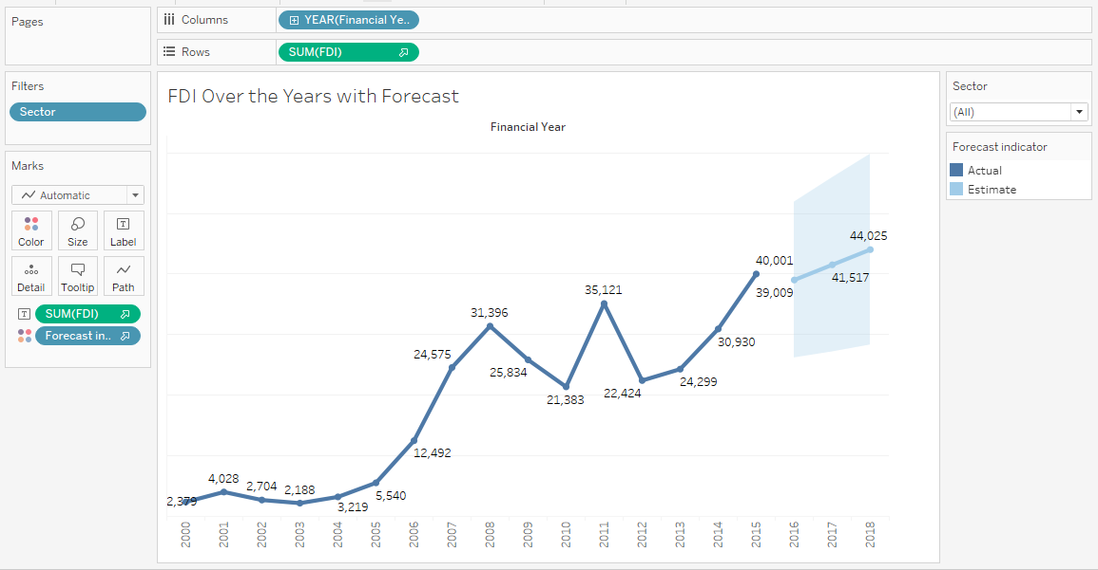
Fig No : 5.1.1 : FDI OVER THE YEAR WITH FORECAST
Foreign Direct Investment (FDI), i.e. investment in one country by the residents of another, includes equity transactions, reinvested earnings and various intercompany capital transactions. FDI is generally considered to be more motivated by longer term considerations than portfolio investment in tradeable securities. The data is recorded in the financial account of the balance of payments, but cross-country comparisons can often be complicated by the different statistical methods used for compilation and the exchange rate chosen for converting local currency into US dollars. Last year saw Karnataka, UP and Kerala attract the bulk of FDI inflows with India coming in fourth place with US$44.9bn. However, some countries did not fare as well and witnessed a notable drop in foreign investment, namely, Delhi, Hydrabad, Tamil Nadu and Assam. Given the fragility of the global economy and the persistent softness in world demand, FDI inflows into the region could face further downward pressure this year. Indeed, this is reflected in a downgrade in the consensus forecast for FDI inflows for a number of countries across the Asia Pacific region.
Our project representing averages of our individual country panelist’s projections, were used to calculate estimates of FDI in relation to country size, i.e. as a share of nominal GDP, and population. The table below shows a small portion of the data from one of our surveys of forecasts Foreign Direct Investment.

5.2: GROUPING OF SECTORS
We have created a group to combine related members in a field. For example, if you are working with a view that shows average test scores by major, you might want to group certain majors together to create major categories. English and History might be combined into a group called Liberal Arts Majors, while Biology and Physics might be grouped as Science Majors. Groups are useful for both correcting data errors (e.g., combining CA, Calif., and California into one data point) as well as answering "what if" type questions (e.g., "What if we combined the East and West regions?).
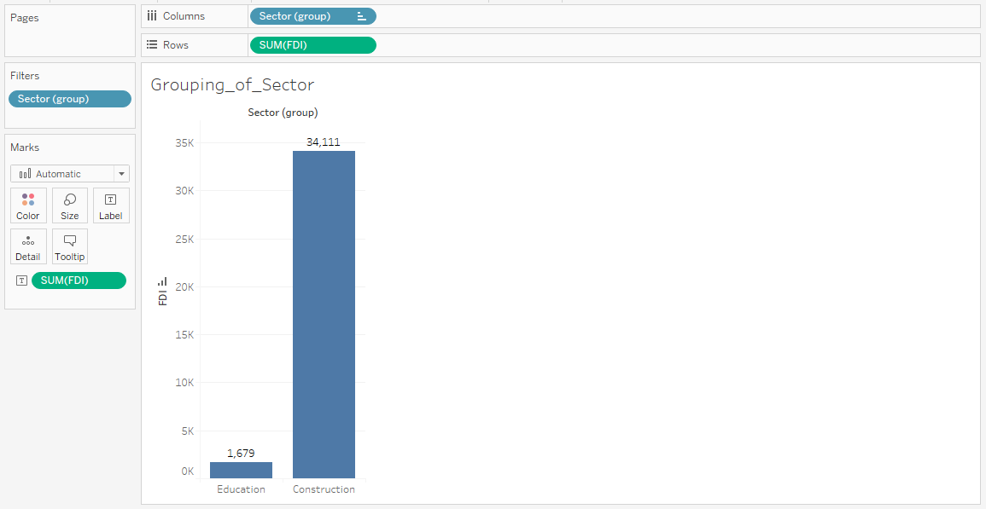
FIG NO. 5.2 : GROUPING OF SECTORS
A horizontal bar will give a good visualization on this. So I set the SUM of the FPI Value as the Columns and Sector as the Rows. I will take the top and bottom 5 of the data by using Filter to the Sector variable. Here you can see that the Service Sector have the biggest FPI Value, followed by Computer Software, Construction, and so on. While Photographic, Coal Production, and so on have the least value than the others.
We can draw a conclusion from this graph but it’s still not clear. If you are an investor and you are trying to decide which sector you should choose, this graph can help but you still need another insight, like : the trends, the growth. You can also filter it by Year to see the Top and Bottom 5 FPI Value each year. In here I also set the sum of the FPI Value as the label so you can see it more clearly. I differentiate the colour between the two to show the contrast between them. (Usually the bottom is defined by red colour, no?)

5.3 : MOST VARIANT SECTOR
We can also draw a conclusion. It seems like the Service and Computer Software Sector have the biggest growth. From the section before, we also know that the Service Sector and Computer Software Sector have the biggest FPI Value. It seems like it’s a good sector to choose. Here I use the filter to filter out the Top 5 and Bottom 5 of the Growth Rate. I also add the Growth Rate as the label in the side-by-side bars. What do you think? Which one gives the better insight?
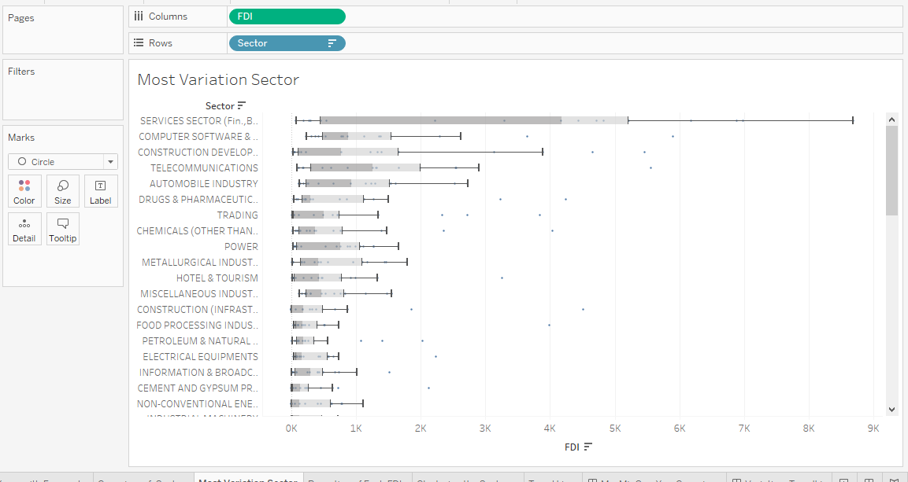
FIG NO. 5.3 : MOST VARIANT SECTOR
At first I was kind a confused because I don’t know how to visualize the growth/decline. At first I thought I can do it with FPI Value and line graph but I want to know which sector have the highest and lowest growth, certainly I can’t drew this conclusion from a line graph. It turns out that using percentage of rate helps. Why didn’t I think of that? It’s okay though, I got another knowledge! So what I did is I set the Year as the Column and the Sector as the Rows. I add the FPI Value in the Text and if you click on it, it will show the The Compound Growth Rate in the Quick Table Calculation.

5.4 : PROPORTION OF EACH FDI
If we want to find out which sector have the most proportion out of all sector? We can see it from the SUM of the FPI Value but it’s hard to compare to one another. So what I did was I use the horizontal bar to visualize this. I use divide it by the sector and use color to define the sum of the FPI Value. I find it easier to draw an insight through this.
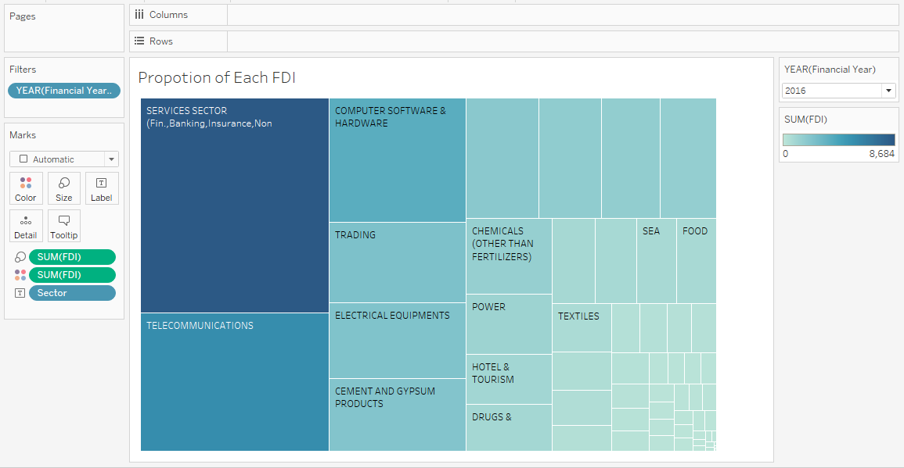
FIG NO. 5.4 : PROPORTION OF EACH FDI
Here we can draw a conclusion that Services, Computer Software, and Construction Development Sector have the most proportion out of the rest of the sector. We all know from before that Services and Computer Software Sector also have the highest FPI Value and Growth Rate. For Construction Development, it have a high FPI Value but the Growth Value is less than Automobile and Telecommunications but still it’s on the Top 5. If we’re still thinking which sector we should choose, we can also try to see the Trend for each sector. We can use Sector as the filter in the Trend section. I also add the percentage of the FPI Value as the labels to show some comparison besides the color depth.
5.5 : CLUSTERING THE SECTORS
We have a lot of sector and some of the sector fall into the same clusters. We can analyze and get some insight through each sector. Here we use the Clusters Analytics function in Tableau to cluster some sector that have similar characteristics.
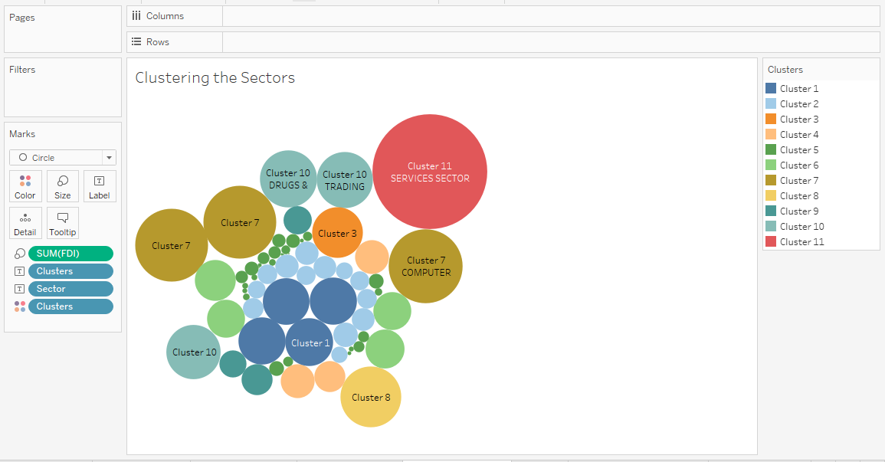
Fig No. 5.5 : CLUSTERING THE SECTOR

Where SSB is the overall between-cluster variance, SSW is the overall within-cluster variance, k is the number of clusters, and N is the number of observations” (Source). This ratio gives a value which determines the cohesiveness of the clusters. So the higher this value, clusters are more closely associated having low within-cluster distance and high between-cluster distance.
We can decide how many clusters we wanted but based on the data, it seems like it fell into 11 different sectors. From this result, we can drew some conclusion if we analyze each cluster separately and hopefully draw some insight of it.
5.6 : TREND ANALYSIS
The last one is we can use the Forecast in Tableau to predict the future outcomes. Of course it’s not 100% accurate and even if it have a high possibility, there may be some external factor that affecting it. But at least from this we can see the tendency of the outcomes.
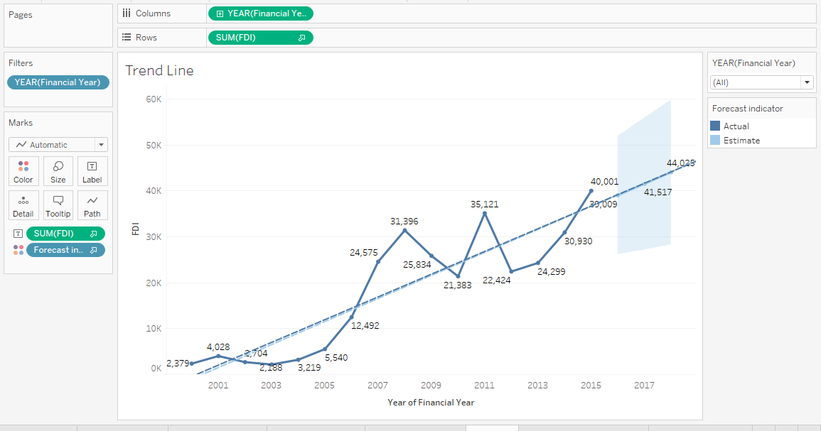
Fig No.5.6 : TREND ANALYSIS

CHAPTER – 6
TABLEAU DASHBOARD
A dashboard is a consolidated display of many worksheets and related information in a single place. It is used to compare and monitor a variety of data simultaneously. The different data views are displayed all at once. Dashboards are shown as tabs at the bottom of the workbook and they usually get updated with the most recent data from the data source. While creating a dashboard, you can add views from any worksheet in the workbook along with many supporting objects such as text areas, web pages, and images.
Each view you add to the dashboard is connected to its corresponding worksheet. So when you modify the worksheet, the dashboard is updated and when you modify the view in the dashboard, the worksheet is updated.
6.1 : CREATING DASHBOARD
Using the Sample-superstore, plan to create a dashboard showing the sales and profits for different segments and Sub-Category of products across all the states. To achieve this objective, following are the steps.
Step 1 − Create a blank worksheet by using the add worksheet icon located at the bottom of the workbook. Drag the dimension Segment to the columns shelf and the dimension Sub-Category to the Rows Shelf. Drag and drop the measure Sales to the Color shelf and the measure Profit to the Size shelf. This worksheet is referred as the Master worksheet. Right-click and rename this worksheet as Key Performance Indicator (KPI). The following chart appears.
Tableau uses a workbook and sheet file structure, much like Microsoft Excel. A workbook contains sheets. A sheet can be a worksheet, a dashboard, or a story. A dashboard is a collection of views from multiple worksheets. A dashboard is a collection of views from multiple worksheets. The Dashboard and Layout panes are available in its side bar. For more details about creating dashboards, see Dashboards. A worksheet contains a single view along with shelves, cards, legends, and the Data and Analytics panes in its side bar. For details on the worksheet workspace, see The Tableau Workspace.
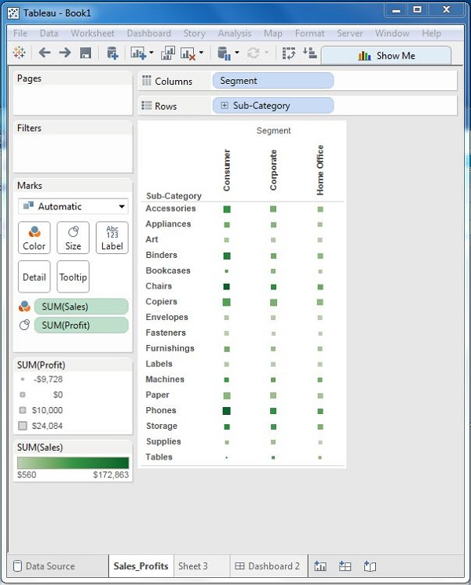
FIG NO. 6.1 : CREATING WORKSHEET
Step 2 − Create another sheet to hold the details of the Sales across the States. For this, drag the dimension State to the Rows shelf and the measure Sales to the Columns shelf as shown in the following screenshot. Next, apply a filter to the State field to arrange the Sales in a descending order. Right-click and rename this worksheet as Key Performance Indicator (KPI).
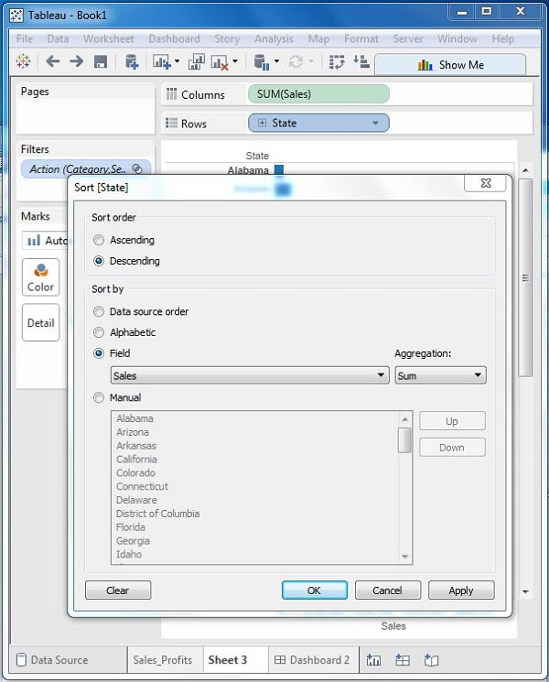
FIG NO. 6.1.1 : CREATING MULTIPLE SHEET
Step 3 − Next, create a blank dashboard by clicking the Create New Dashboard link at the bottom of the workbook. Right-click and rename the dashboard as Employee Attrition Dashboard.

FIG NO. 6.1.2 : BLACK DASHBOARD SHEET
Step 4 − Drag the two worksheets to the dashboard. Near the top border line of Total Number of Employee with respect to department worksheet, you can see three small icons. Click the middle one, which shows the prompt Use as Filter on hovering the mouse over it.
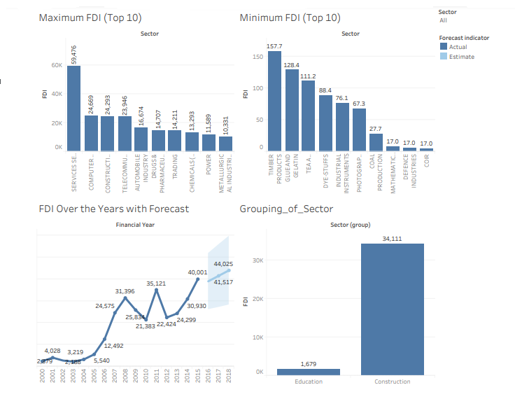
FIG NO. 6.1.3 : DASHBOARD 1
Step 5 − Now in the dashboard, click the box representing Sub-Category named Machines and segment named Consumer. You can notice that only the states where the sales happened for this amount of profit are filtered out in the right pane named Resignation Prediction. This illustrates how the sheets are linked in a dashboard.
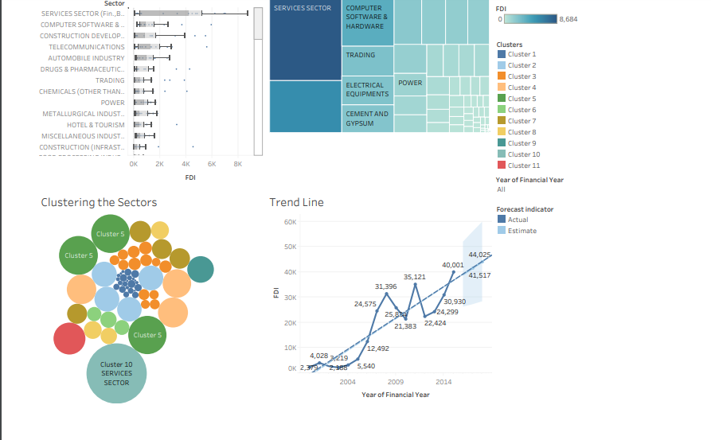
Fig No. 6.1.5 : DASHBOARD 2

Here we can see that the forecasting give the future outcomes of the lines increasing. We can use filter to see the forecasting of each sector to give a much detailed forecasting.

CHAPTER – 8
CONCLUSIONS
In this term project we understood the dynamics of FDI. Importance and Implications of FDI goes a long way in determining the growth of an economy. The role of FDI has been of great importance for the country, moreover in the recent past. Through the study done in this term project we developed understanding to interpret FDI trends. We would like to thank our supervisor for letting us choose this topic and for his constructive guidance. Also we are thankful to the authors of the cited references which made our study easier and making our term-project a successful study.

CHAPTER – 8

EXPERT COMMENTS

Tableau Data Analysis tool should create confidence in their employee by considerable investment in business, they hire services from other service providers instead of this they should go for collaborations and that too with good companies. who are
number br 2 in their respective sector, if you hire services of number 4-5 in that
sector Quality and Overall Efficiency goes down. More importantly, a Tableau service
provider should understand the company’s business first, then should create a
flexible environment for their customer and should allow two way interactions.
Particularly, in the business of Pharmaceuticals, Tableau service provider must be
made is mind to face the hassles in Licensing, Drug Regulation Acts, Authorized
Signatory, etc.

Tableau players must understand that they provide Place utility, out of 4 P’s of the
business utilities, so they should consider it as prime focus to provide the Place
Utility to their customers. As far as pricing is concerned, they should consider an overall Profitability in the business instead of trying to generate profit at each link of the chain.
In literal sense, 3 PL must act as a Shadow of their customer without any self-policies, even with flexible IT systems.

Mr. Mohammed Tanzeem Agra
CEO – XERXEZ SOLUTIONS

Bibliography
SL No | RESOURCES
1. | FDI confidence index, A T Kearney, Global Business Policy Council, 2005 Vol. 8.
2. | Report of the steering group on foreign direct investment, Planning Commission, Govt. of India, August 2002.
3. | Trends and Recent Developments in Foreign Direct Investment Part I, Chapter 1, INTERNATIONAL INVESTMENT PERSPECTIVES: 2006 EDITION
4. | Report of the committee on compilation of FDI in India, October 2002.
5. | World Investment Reports, 2001-06.

